Technical Documentation - Audio Car

Authors: Garv Bhumbla, Zane Bush, Emerson Hall, Navagana Jha, & Disha Rachur

Table of Contents
- Objective ………………………………………………………………….. 3
- Constraints ………………………………………………………………… 5
- Technical Design …………………………………………………….……. 7
  - Hardware
  - Software
  - Power Supply
- Ethics ………………………………………………………………………(2 pages)
  - Design Originality
  - Ethical Considerations
- Self-critique ………………………………………………………………..(2 pages)
- Revision Plan ………………………………………………………………(2 pages)
- Individual Reflections ………………………………………………(½ page per member)
- Appendix………………………………………………………………..#

Objectives
The main objective of this project is to create a working RC car that can recognize and move to multiple fixed audio frequencies. Each team received a kit of parts to utilize while designing the car. It is important to note that the objective of the design is to utilize inexpensive ideas so there is no financial strain. The team is free to utilize parts they buy with their own budget, however, if any component burns or gets damaged, it is the team’s responsibility to provide and pay for a new one.

Key Roles:
- Garv Bhumbla: Responsible for hardware, power supply and wiring components.
- Zane Bush: Responsible for operating the RP4, hardware, some code - involved in all areas.
- Emerson Hall: Handles most of the coding and testing code, operating RP4.
- Navagana Jha: Responsible for checking and modifying the code if issues arise, helps with documentation.
- Disha Rachur: Responsible for task organization/allocation, documentation, some coding, and some wiring.

Constraints
- What are the constraints, the boundary conditions for the project. Discuss these in such a way that you explain how they affected decisions made.
- The parts given to the group limited our ability on ways to power the car. We were able to utilize a 24V power supply to power the car. With limited voltage, we had to think of different ways that the car can be powered through the parts given such as transistors, op-amps, processors, convertors, and other items. With the 24 V that is given to us, we must design a way for the car to work throughout this voltage by distributing the voltage correctly.
- The car is required to draw figures. The three that our car will be tested on will be moving the car in a straight line, a square shape, and a figure 8 position. The next condition of this design requires the car to recognize a single sound frequency and be able to move towards it.
- All code must be written in Python and will be tested through the Raspberry pi.
- As we tested the functionality of our car, the motors were running into problems. Motor 2 kept falling off after running during our figure testing. For instance, after the robot created the square, the wheel started to come off causing issues. This showcases that the motors we were given can present a constraint as well.

Technical Design

Raspberry Pi
Make sure to put the SD card in the Raspberry Pi before connecting it to the monitor.
GPIO Diagram

Git
If multiple people are working on the project at the same time, make sure to do a git pull before a git commit so you are committing changes to the most updated version of the project files.

H-Bridge & DC Motors
H-bridge in standalone mode: IC chip requires 5V for its internal logic, supplied from the pi hat, and the other Vcc powers the motors using an external power supply (we used the DC power supply to test standalone mode). We found that when a high signal was given to one of the odd input terminals on either side (pins 1A or 3A) the motor would turn counterclockwise and if the even input terminals were high (2A and 4A) the motor would turn clockwise. We observed that both motors moved at different speeds but increasing voltage generally caused them both to speed up. To change input signals, we would simply take a 5V line coming from a power supply to one of the input terminals and connect it to the other causing a change in direction. If both input terminals on either side of the H-bridge were the same (both high or both low) that motor would not run at all.
Transfer function: A range of 5.0V(minimum voltage required) - 12.0V (max voltage supplied by power supply) was used to collect RPM data using the code RPMcalculator.py. After recording RPMs, voltage (x-axis) vs. RPM (y-axis) and used a line of best fit to find the slope of the two curves (one for each motor). The graphs are displayed in Figure 1.3 and Figure 1.4 below. The best fit line equations for each motor are y = 41.044x - 83.809 and y = 42.240x - 82.75 with the slope representing K for each motor.

 | 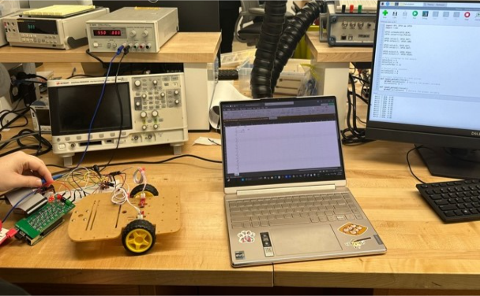
Figure 1.1: Calculations obtained to derive the transfer function. | Figure 1.2: Experimental Setup for RPM.
These are the values based on the newest calculations performed after switching out a faulty motor. In our initial characterization, we found that the car swerved to the left, however, the motor pin values for the motors were switched which caused this issue, after verifying the motors, the car moved straight. Here are videos of the car traveling in a straight line: StraightCar1 and StraightCar2.

Power Supply
Simulation of push-pull amplifier: Referenced designs can be found in Appendix Section A.1.
Using Multisim, the circuit at Figure 1.1 was simulated using 10K ohm resistors. For this initial circuit, two positive voltages (2.374 V and 21.289 V) were achieved. Following additional research, it was noted (Figure A.1.2.1) the 24V source was in parallel with the entire branch with the diodes and resistors. Using the design in Figure 1.2, a positive and negative voltage on each end was achieved (-9.78 V and 14.50 V). To achieve voltages to be +/- 12V, different resistors were used to experiment with adding resistors between the two transistors, and on the different legs of the transistors; however, the correct voltages were not achieved. After further experimentation and removing the third resistor in the bottom leg of the bottom MOSFET, using 10K resistors for both the resistances, and verifying that we used the point between the two resistors as our virtual ground (we were originally using the point in between the two transistors), we were able to get +/- 12V. However, when adding loads, the voltages become unstable so +/- 12V were not maintained. After further research, it was found multiple push-pull amplifier designs incorporated op-amps. Using an op-amp assists the MOSFETs operate with their optimal range, as the negative feedback improves stability and can help with phase splitting. Inserting resistors in between the MOSFETs helped to stabilize the voltage, however, resistance values that were too high such as 10k and 5k ohms limited the current flow to the MOSFET gates since the resistors are connected to the feedback loop of the op-amps, so 10 ohms and 5 ohms were used.

Microphones
Characterize microphone:
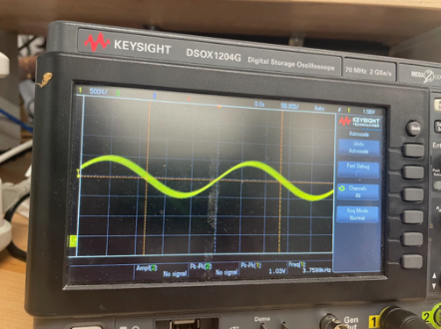 | 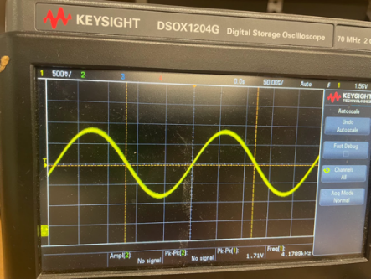 | 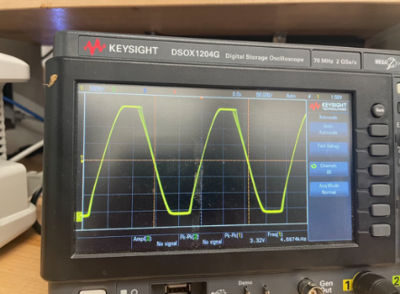
Figure 3: Output for 3686 Hz | Figure 4: Output for 4186 Hz | Figure 5: Output for 4686 Hz
We found for all these values; the microphone measured a similar frequency in our output reading. However, we observed that when input frequencies were less than 500 Hz and more than 9 kHz, they would begin to become inaccurate and unstable. This does not concern us because, as stated above, these frequencies are out of scope for this project. When testing our gain increase on the microphone, we discovered that an increase in gain would also increase the output voltage of the microphone and allow it to pick up sounds that were further away from the microphone. When our gain was low, we would have to essentially rest our phones on the microphone to pick up sounds but when gain was increased the source could be slightly further away. Similar results were achieved for both microphones, so it can be concluded that both the microphones are functional and similar in behavior.

[General Notes - will eventually be deleted]
- This is the main section of the document. It should contain multiple subchapters fully describing all aspects of the design: hardware and software.
- Yes, this also includes your power supply. We recommend a separate subsection for this in the Technical Design part of the document.
- You may reference work from your prior submissions. You will want to “clean up” the work and use the key parts in the write up. You will also need to reference the file so we can find it (week, name of file, etc...)
- You may use snippets of your software’s primary code where needed. Otherwise reference your code with information to find it (file name, line numbers, etc....)
- Do not describe reference material here. If you did not design it, but are referring to it, put it in the appendix.

Ethics
- What did your team do to ensure that your design was your own
- If this design was truly for a product used by others, what would your group need to ethically consider? (Note, you may want to review the Engineer’s code of ethics https://www.nspe.org/resources/ethics/code-ethics).

Self-critique
- How did the team perform based on your results and your expectations? Consider different aspects: teamwork, hardware, software, whatever you think is important to your critique. Note, critiques can discuss good and not-so-good things.

Revision Plan
- Based on your results, describe changes that your team could make with respect to design choices, methods, etc... to improve the design if you had time for another iteration.
- Describe what might be different if this were a real product versus a class project.

Individual Reflections
- Each person independently writes a self-reflection on the project

Appendix
- You may provide links to main reference materials (specifications)
- If you watched a video or referred to a website, you must reference it in the main part of the document and provide the link in the Appendix.
- Use the Appendix for other items that your team finds necessary and important. Do not use the appendix as a “spam” location for all kinds of material.
- Separate the Appendix into meaningful sections: A.1, A.2, A.3, for example

A.1: Push-Pull Amplifier to split 24VDC into -12VDC an 12VDC
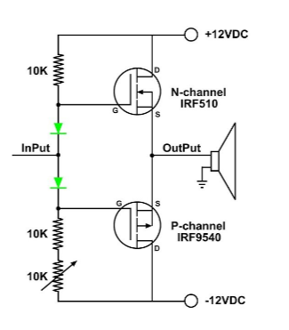 |  | 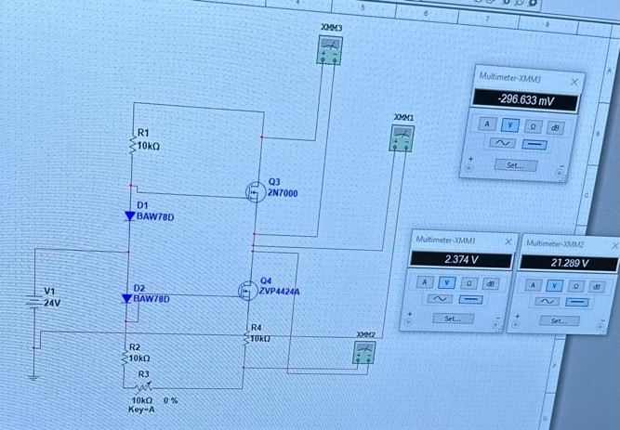
Figure 1.1: Design 1 – Inspiration and Multisim implementation
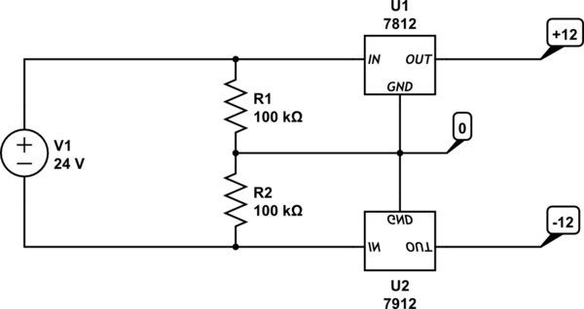 |  |  | 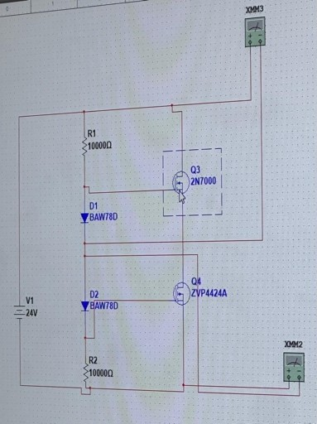
Figure 1.2: Design 2 – Inspiration and Multisim implementation
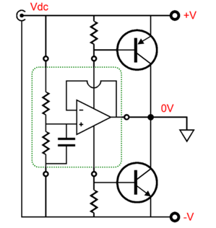 | 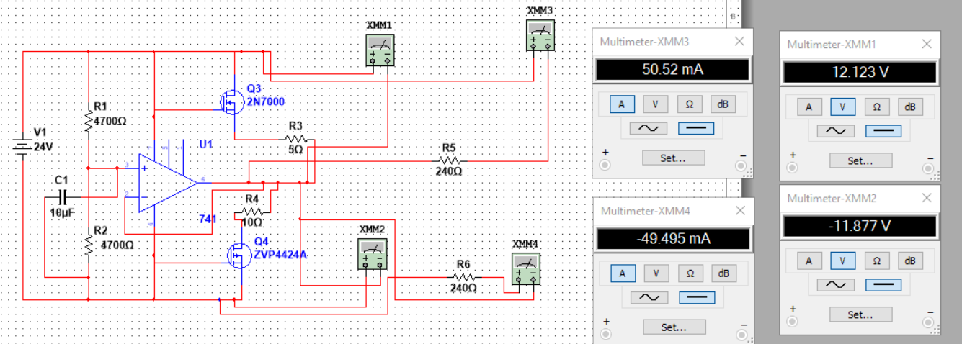
Figure 1.3: Design 3 – Inspiration and Multisim implementation with loads

